VMware Pro Cloud Services for Private Cloud - VMware Cloud Foundation-NSX 9.x Low-Level Design and Architecture
Client Confidential -
AMERICAN EXPRESS TRAVEL
RELATED SERVICES COMPANY, INC.


You can find the most up-to-date technical documentation on the VMware website at:
https://docs.vmware.com/
Broadcom®
3421 Hillview Ave.
Palo Alto, CA 94304
www.vmware.com
Copyright© 2026 Broadcom® All rights reserved. Copyright and trademark information.
Contents
Glossary of Terms 5
1. Version History 9
2. Document Overview 10
Executive Summary 10
Document Focus 11
Physical Design 11
Sizing Workbook 11
Naming Convention Document 11
Solution Specification Workbook(s) 12
Solution Verification Workbook(s) 12
3. NSX Conceptual Design 13
4. NSX Logical Design 15
Physical Network Architecture 15
Virtual Infrastructure Architecture 19
NSX Base Design 19
VLANs and Subnets 22
Virtual Switches 23
VCF Fleet Level Components Network Design 26
Transport Node and uplink Policy Design 28
NSX Edge Transport Design 31
Edge Cluster Design 34
Transport Zone Design 35
Geneve Overlay 37
NSX Federation and Routing Design 38
Lifecycle Management 45
Backup and Restore 47
5. Appendix 49
6. References 50

Glossary of Terms
Term | Description
Compute Manager | A compute manager is an application that manages resources such as hosts and VMs. One example is vCenter Server.
Control Plane | Computes runtime state based on configuration from the management plane. The control plane disseminates topology information reported by the data plane elements and pushes stateless configuration to forwarding engines.
Data Plane | Performs stateless forwarding or transformation of packets based on tables populated by the control plane. The data plane reports topology information to the control plane and maintains packet level statistics.
External Network | A physical network or VLAN not managed by NSX. You can link your logical network or overlay network to an external network through an NSX Edge. For example, a physical network in a customer data center or a VLAN in a physical environment.
NSX Manager | Node that hosts the API services, the management plane, and the agent services. The NSX Manager is an appliance included in the NSX Data Center installation package and represents the Management and Control Plane of the NSX deployment. You can deploy the appliance in the role of “nsx-manager nsx-controller” or “nsx-cloud-service-manager”. Currently, the appliance only supports one role at a time. The TalkTalk network virtualisation design requires the appliance to be deployed with the “nsx-manager nsx-controller” role.
NSX Manager Cluster | A cluster of three NSX Managers that can provide high availability.
NSX Controller | As a component of the control plane, the controllers control virtual networks and overlay transport tunnels.  For stability and reliability of data transport, NSX deploys the NSX Controller as a role in the Manager cluster which consists of three highly available virtual appliances. They are responsible for the programmatic deployment of virtual networks across the entire NSX architecture.
NSX Edge Node | Component with the functional goal to provide computational power to deliver the IP routing (connectivity to networks that are external to the NSX domain) and the IP services functions.  Edge Nodes are pooled in clusters for scale-out and redundancy.It leverages the data plane development kit (DPDK) for faster packet processing and high performance. The TalkTalk network virtualisation design includes the appliance in a VM form factor.
NSX Edge Cluster | Represents a collection of NSX Edge node appliances that have the same settings and protocols involved in high-availability monitoring. An NSX Edge Cluster is required to create a tier-0 or tier-1 gateway with stateful services (e.g., NAT, load balancing, etc.).  An NSX Edge cluster should only host edges of identical types and capabilities (VM or bare metal).  An NSX Edge cluster does not have a one-to-one relationship with a vSphere cluster; therefore, a vSphere cluster can run multiple NSX Edge clusters, or an NSX Edge Cluster can span numerous vSphere clusters.
Overlay Logical Network | Logical network implemented using Layer 2-in-Layer 3 tunnelling such that the topology seen by VMs is decoupled from that of the physical network.  NSX uses GENEVE (Generic Network Virtualization Encapsulation) as the underlying overlay protocol.
Segment | A segment performs the functions of a logical switch. A segment gives tenant network administrators the logical equivalent of a physical Layer 2 switch, allowing them to connect a set of VMs to a common broadcast domain. A segment is a logical entity independent of the physical hypervisor infrastructure and spans many hypervisors, connecting VMs regardless of their physical location.  Segments can be overlay or VLAN based depending on the traffic type parameter from the parent transport zone.  A segment is also known as a logical switch.  In a multi-tenant cloud, many segments might exist side-by-side on the same hypervisor hardware, with each Layer 2 segment isolated from the others. Segments can be connected using gateways, which can provide connectivity to the external physical network.
Segment Port | Segment attachment points to establish a connection to a virtual machine network interface or a logical router interface. The segment port reports applied switching profile, port state, and link status.  A segment port is also known as a logical switch port.
Gateway (Logical Router) | Can provide centralized services and North-South connectivity so that workloads can access external networks and East-West connectivity between logical networks.  Two types of gateways exist within NSX:  Tier-0 Gateway (also known as Tier-0 Logical Router): interfaces with the physical network and exchanges routing information with external routers via static routing or eBGP. In active-standby mode, the gateway can also provide stateful services.  Tier-1 Gateway (also known as Tier-1 Logical Router): provides default gateway services for VMs attached to segments. It connects to one tier-0 gateway for northbound connectivity and one or more overlay networks for southbound connectivity.  Both types of gateways can include a distributed router (DR) and a service router (SR). Distributed routers are instantiated on transport nodes while service routers are being executed within NSX edge nodes. Service routers provide centralized functions such as NAT or load balancing.
Logical Router Port | Logical network port to which you can attach a segment port or an uplink port to a physical network.
Fabric | A collection of transport nodes, edge clusters, profiles (e.g., uplink profiles), transport zones, and compute managers that make up the virtualized network environment.
Transport Node | A node capable of participating in an NSX overlay or NSX VLAN networking. Any node can serve as a transport node if it contains an NSX Virtual Distributed Switch (N-VDS) such as ESXi hosts and NSX Edges.  NSX currently supports VMware ESXi and KVM hypervisors. The N-VDS implemented for KVM is based on the Open vSwitch (OVS) and is platform independent.  NSX Manager always configures the N-VDS for ESXi hosts.  There are two types of transport nodes: host transport nodes and edge transport nodes.
Physical Interface (pNIC) | Network interface on a physical server that a hypervisor is installed on
Uplink Profile | Defines policies for the links from hypervisor hosts to NSX segments or from NSX Edge nodes to physical switches. The settings defined by uplink profiles might include teaming policies, active/standby links, the transport VLAN ID, and the MTU setting.
Transport Zones | Collection of transport nodes that defines the maximum span for segments. A transport zone represents a set of similarly provisioned hypervisors and the segments that connect VMs on those hypervisors. There are VLAN transport zones and overlay transport zones.
Distributed Firewall | NSX distributed firewall is a hypervisor kernel-embedded firewall at the virtual NIC level that enforces micro-segmentation policies and provides visibility and control for virtualized workloads and networks.
Policy | A security policy includes various security elements including firewall rules and service configurations.  Security Policy was previously named a Firewall Section.
Rule | A set of parameters with which flows are evaluated against and define which actions will be taken upon a match. Rules include parameters such as source and destination, service, context profile, logging, and tags.
Group | Groups include different objects that are added both statically and dynamically and can be used as the source and destination field of a firewall rule. Groups can be configured to contain a combination of segments, segment ports, virtual machines, virtual network interfaces, IP/MAC addresses, AD user groups and other nested groups. Dynamic inclusion of groups can be based on tag, machine name, OS name or computer name.  When you create a group, you must include a domain that it belongs to, and by default this is the default domain.  Groups were previously called NSGroup or security group.
Service | Defines a combination or port and protocol. Used to classify traffic based on port and protocol. Pre-defined services and user-defined services can be used in firewall rules.
Context Profile | Defines context aware attributes including APP-ID and domain name. Also includes sub attributes such as application version, or cipher set. Firewall rules can include a context profile to enable Layer-7 firewall rules.
vNIC | The emulation of a physical network adapter (NIC). Allows virtual machine connectivity to a network. Virtual machines typically have at least one vNIC but can have multiple vNICs depending on their use, environment configuration, or security posture.
Filter | The dataplane implementation of DFW rules on a vNIC associated with a virtual machine.

Version History
Date | Ver. | Author | Contributors | Description | Reviewers
9th Apr 2026 | V1.0 | Bipin Bihari Panda | Khaleel Syed | Initial VCF-9 NSX LLD | David Serafine
16th Apr 2026 | V1.1 | Bipin Bihari Panda |  | Updated after review | David Serafine

Document Overview
This solution design document is created by VCF Professional Services to support the deployment of the Solution for Customer.
This document may be accompanied by other documents that focus on the implementation and operation aspects of the engagement, such as installation guides, solution specification and verification workbooks if implementation services are being performed.

Executive Summary
This document is part of a low-level design that is being created for the AMEX as part of a VMware Cloud Foundation-9 design. To individually review the designs of individual elements, this document has been created which will eventually be included in the complete low-level design document that will be delivered to AMEX.
It covers the specific Core NSX Design for VMware Cloud Foundation along with NSX Federation for Management and Workload Domains, as well as Routing Design for both AZ1 and AZ2.
The following section documents the specific NSX architecture for the American Express VCF 9 on-premises deployment across two availability zones. This design implements the Dual Availability Zone Design based on NSX Edge Node HA model, with dedicated NSX Edge Clusters per rack and NSX Federation providing centralized policy management across both Local Managers.
​​This software defined networking design for NSX Datacenter provides details of the NSX Datacenter components deployed in both Mgmt. and VI Workload Domains - as well as specifics about the Routing Design for both workload domain and NSX Federation Extension Design for the Mgmt. Domain.

Architecture Overview
The NSX architecture spans AZ1 (Rack 1) and AZ2 (Rack 2) within a single data center region. Key architectural characteristics of this deployment are as follows:
- NSX Federation with a three-node Global Manager cluster provides centralized security policy and segment management across both Management NSX domains.
- Each availability zone hosts an independent three-node NSX Local Manager cluster with a Virtual IP (VIP) for API and UI access.
- Dedicated NSX Edge Clusters per availability zone host the NSX Edge nodes. Edge nodes cannot move between availability zones.
- A single Tier-0 stretched gateway operates in Active/Active mode with Primary AZ1 and Secondary AZ2 locations.
- A single Overlay Transport Zone is shared across all clusters within each NSX domain, ensuring all VPCs and overlay segments are available to all ESXi hosts and Edge nodes.
- Fleet-level management components (VCF Automation, VCF Operations, VCF Operations For Logs,VCF Operations For Networks and Identity Broker) are deployed on an NSX overlay segment via the Stretched T1 gateway, addressing portability across both availability zones.
- Distributed Firewall (DFW) is enforced on all ESXi host vNICs across both availability zones, with policy pushed by the NSX Local Managers and rules defined in the Firewall Rules Workbook.

Document Focus
This document, the Low-Level Design Document, is one of five main documents that will collectively form the Low-Level design documents for the solution.
This includes the following content, which may be presented as one or more technical documents as required by the solution.

Physical Design
The physical design serves as the final, implementable blueprint that translates the high-level objectives and architectural outlines of the conceptual and logical designs into specific, actionable details. The physical design details the exact hardware, including server models, storage arrays, and network devices, as well as their configurations.
It provides intricate network topologies, complete with IP schemes and VLAN settings, specifies storage layouts down to RAID levels and disk types, and outlines concrete security mechanisms such as firewall configurations and encryption protocols. The physical design also covers specifics on availability and disaster recovery solutions like failover clusters and backup schedules.
The physical design incorporates the management and monitoring tools to be used and how they will be configured. Essentially, the physical design is the comprehensive guide that the implementation team will follow to build the system, ensuring that it meets both functional and non-functional requirements and aligns closely with the organizational objectives.

Sizing Workbook
The sizing workbook is a vital tool that systematically outlines the resource requirements such as CPU, memory, storage, and networking that are needed for a specific architecture.
The sizing workbook is a living document which incorporates various elements, including detailed calculations guided by formulas to ensure that the architecture can meet the calculated sizing which ideally would align with the organization's objectives and constraints.
The sizing document incorporates the licensing which will be consumed by the solution and if any design decision violates the licensing constraints or if additional licenses need to be procured as part of the scalability exercise.

Naming Convention Document
The naming convention document serves as a critical blueprint for organizing and managing elements within a cloud infrastructure. This document delineates a standardized naming scheme, covering elements of the VMware by Broadcom solution to ensure uniformity, easier management, and streamlined troubleshooting.
The naming convention outlines specific syntax rules including permitted characters, name length, and capitalization guidelines, as well as semantic conventions to imbue names with functional, environmental, or locational significance.
Additionally, the document addresses rules for prefixes or suffixes. The <component> naming convention document is considered a structured approach to achieve communication among team members and stakeholders, and it aids significantly in the complex task of managing the solution.

Solution Specification Workbook(s)
The solution specification workbook(s) serve as a set of guides that outline the specific settings required to implement a VMware by Broadcom solution. These detailed documents the precise configurations for each solution, aligning closely with the earlier conceptual, logical, and physical design phases.
Solution specification workbooks cover a wide range of elements, from exact hardware settings for servers, storage, and network devices to software versions and patches, as well as configurations like VM sizes and resource allocation. The workbooks also incorporate network settings, including VLANs and IP schemes, layout storage configurations, and detail mechanisms for high availability, disaster recovery, and security.
The solution specification workbooks ensure that deployment consultants and cloud administrators have a consistent, accurate roadmap for successfully realizing the architectural design and meeting business objectives.

Solution Verification Workbook(s)
The solution verification workbook(s) act as structured guides for the comprehensive testing and validation of the VMware by Broadcom solution prescribed within the architecture. These workbooks are pivotal for quality assurance, defining test objectives aligned with the solution's functional and non-functional requirements, outlining specific test scenarios and procedures.
The solution verification workbooks provide detailed step-by-step instructions for executing each test, including the setup requirements, and expected outcomes, and feature explicit pass/fail criteria to quantify success or failure. The workbooks also have designated sections for recording actual test results, documenting anomalies or issues encountered.
The solution verification workbooks are an anchor for ensuring the implemented VMware solution is ready for production, meeting both technical specifications and organizational goals.

NSX Conceptual Design
This section describes the NSX-T conceptual design for the engagement. The conceptual design is meant to be a high-level overview of the design for the engagement.
The key components in the conceptual design are described below:

Table 3-1. Physical Network Design Decisions

NSX-T Component | Description
Perimeter firewall | This is the physical firewall, which exists at the perimeter of the datacentre. This does not enforce security on the application traffic flows in the internal network, legacy trust zone flows, but only enforces security control on traffic with external non-trusted network-based services.
External network | Network external to the NSX domain. Connectivity to and from the external network is through the NSX Edge cluster. This will include internet connectivity and Citrix Remote Desktop Services (RDS).
NSX Edge cluster | The Edge cluster Tier-0 router handles North-South traffic entering and leaving the NSX domain, by way of static routing or Border Gateway Protocol (BGP).
NSX Distributed Router (DR) | The DR is optimized for forwarding in the virtualized space, that is, East-West communication between VMs. This is achieved by it being installed in the kernel within each NSX participating host (Transport Node).
NSX Services Router (SR) | The SR is instantiated upon a centralized service such as; external routing, DHCP and NAT, being configured. The SR is built upon the Edge Node VMs as a central resource pool.
Two-Tier Routing | NSX-T introduces a two-tier routing architecture, composed of Tier 0 and Tier 1 routers (SR/DR). This brings specific advantages such as allowing inter-tenant traffic to occur all within the same hypervisor.
Internal Segments | These networks represent the main workload networks that are connected to a Tier-1 distributed logical router that sits behind the NSX Edge cluster Tier-1 router. These networks consist of GENEVE-based NSX-T logical switches to which virtual machine workloads directly connect.
Distributed firewall | Distributed firewall provides a layer L2 to L4 stateful firewall implemented per VM vNIC level. An instance of DFW is located between the VM and the virtual. All ingress and egress packets to and from this VM must pass through the DFW. Thus, the DFW could be used to protect workload-to-workload traffic within a single Layer 2 segment using MAC address rule sets and across different segments using L3/L4 rules using IP addresses and TCP/UDP ports.

Figure 3-1. NSX Key Components

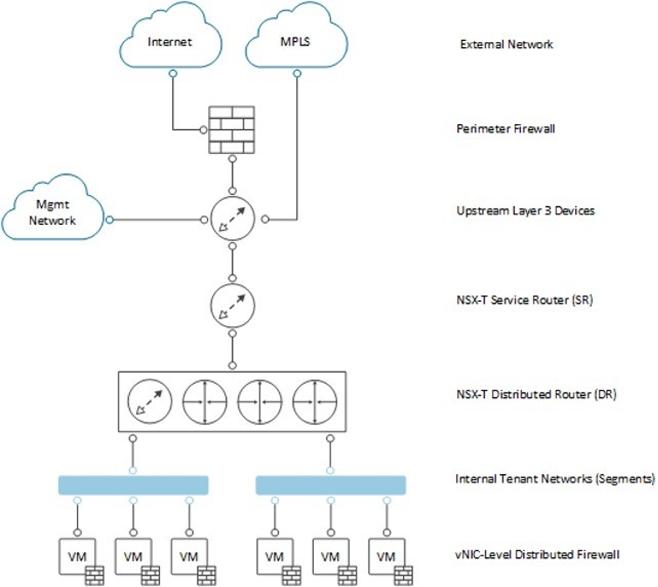

NSX Logical Design
VMware Cloud Foundation (VCF) architecture provides a scalable and secure framework for deploying and managing Software-Defined Data Centres (SDDCs). VCF integrates core VMware technologies, including vSphere, vSAN, and NSX, to deliver a unified, automated platform for private and hybrid clouds. The below logical design highlights the key components and their relationships.

Figure 3-2. NSX Logical Design
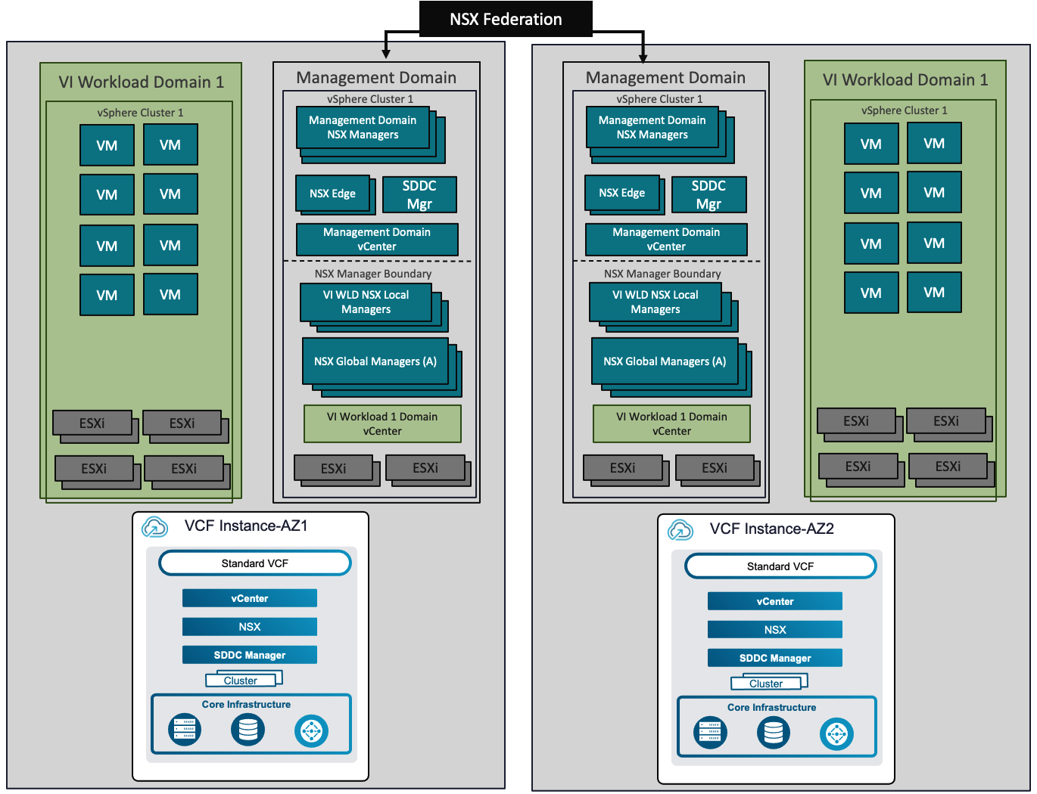

Physical Network Architecture
The current AMEX physical network is based on Cisco 9000X Catalyst switch solution which is configured as a single stack to provide the Layer-3 services to meet all the requirements for the NSX Datacentre proposed implementation.
Full details of AMEX physical network solution are outside the scope of this design document.

Considerations:
o In a design that uses Layer 2 transport, top of rack and end of row switches form a switched fabric.
o The upstream Layer 3 devices – Top of Rack switches (ToR) - terminate each VLAN and provide default gateway functionality.
o Uplinks from the top of rack switch to the upstream Layer 3 devices – Top of Row switches (ToR) - are 802.1Q trunks carrying all required VLANs.
o Upstream Layer 3 devices – Top of Rack switches (ToR) – can establish routing adjacency using a dynamic routing protocol.

Figure 3-3. Physical L2/L3 Switched Design
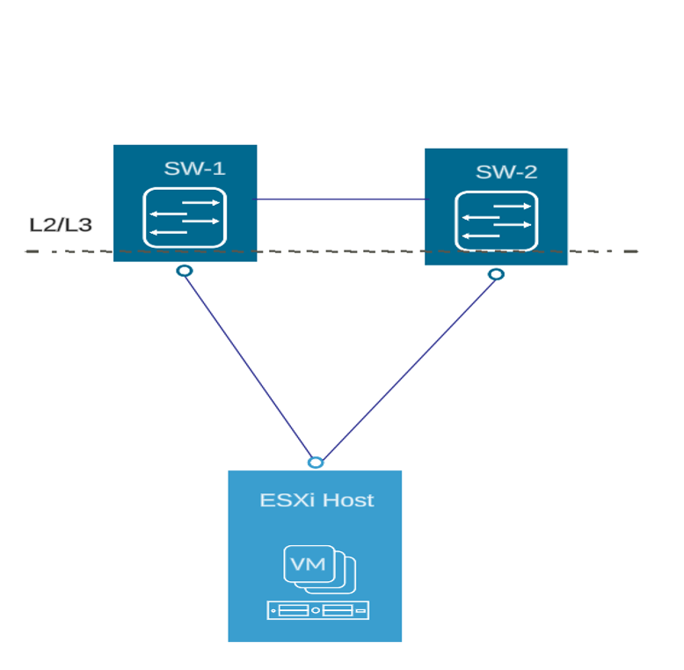

The NSX Datacentre design includes details of the network topology required to connect the physical switches and transport nodes, determining switch port settings for VLANs and link aggregation, and designing routing. You can use VMware Validated design guidance with most switch types and network connectivity.

The following best practices were ratified before initiating the NSX Datacentre design within the AMEX VCF platform:

o Configure redundant physical switches to enhance availability.
o Configure switch ports that connect to ESXi hosts manually as trunk ports. Virtual switches are passive devices and do not support trunking protocols, such as Dynamic Trunking Protocol (DTP).
o Modify the Spanning Tree Protocol (STP) on any port that is connected to an ESXi NIC to reduce the time it takes to transition ports over to the forwarding state, for example using the Trunk PortFast feature found in a Cisco physical switch.
o Configure jumbo frames on all switch ports, inter-switch link (ISL) and switched virtual interfaces (SVIs).
VLAN requirements will be listed in the VCF Configuration Workbooks spreadsheets specific for both Mgmt and VI Workload Domain.
Table 3-2. Physical Network Design Decisions
Design Requirement ID | Design Requirement | Justification | Implication
NSX -REQD-PHY-001 | The network underlay for use with NSX will be a Layer 3 transport network. | As described in section, AMEX current physical setup relies on a Layer 3 transport layer. | VLANs span multiple racks.
NSX -REQD-PHY-002 | Use redundant physical connections to physical network fabric for each transport node (ESXi). | This design uses two (2) 25GbE links to each ESXi host and provides redundancy and reduces the overall design complexity. | Configuration needs to be identical between physical switches.
NSX -REQD-PHY-003 | Use VLANs to segment physical network functions.  Below VLAN’s will be configured as L3 in Physical Network.  1-Mgmt  2-vMotion  3-Host TEP  4-Edge TEP  5-RTEP  6-BGP Uplinks | Supports physical network connectivity without requiring many NICs.  Isolates the different network functions of the SDDC so that you can have differentiated services and prioritized traffic as needed. | Requires uniform configuration and presentation on all the trunks made available to the ESXi hosts.
NSX -REQD-PHY-004 | Configure the BGP in the Physical Switch and share the AS number for NSX Tier-0 peering. | BGP will be used as the preferred routing protocol between Physical and Virtual environments. Details will be there in the configuration workbook. | Require BGP to be set up in the Switches.
NSX -REQD-PHY-005 | Configure the MTU size to at least 1700 bytes (recommended 9000 bytes for jumbo frames) on the physical switch ports, vSphere Distributed Switches, vSphere Distributed Switch port groups, that support the following traffic types:  · Geneve (overlay)  · vSAN  · vMotion  vSphere Replication | Improves traffic throughput.  Supports Geneve by increasing the MTU size to a minimum of 1600 bytes.  Geneve is an extensible protocol. The MTU size might increase with future capabilities. While 1,600 is sufficient, an MTU size of 1,700 bytes provides more room for increasing the Geneve MTU size without the need to change the MTU size of the physical infrastructure. | When adjusting the MTU packet size, you must also configure the entire network path (VMkernel ports, virtual switches, physical switches, and routers) to support the same MTU packet size.

Virtual Infrastructure Architecture
The SDDC virtual infrastructure consists of workload domains. The SDDC virtual infrastructure aligned with VMware Cloud Foundation framework includes a management workload domain, that contains the management cluster, and multiple virtual infrastructure workload domains that will contain a compute cluster to host customer workload.
Management Cluster
The management cluster runs in the Management Workload Domain and hosts the virtual machines that manage the SDDC and will be deployed as part of the initial bring up.
The Management Workload Domain and cluster will be outlined in the VCF Design sections of the document since it will follow closely the VCF standard and Consolidated deployment process.
Part of the NSX Management plane components will be deployed in this cluster as part of the VCF NSX VI Workload workflow creation. In future if AMEX requires a different VI-WLD then the same existing VI-WLD NSX Manager cluster can be leveraged.
Compute Cluster
The compute cluster hosts all tenant payload workloads, or end user virtual machines. The hosts in this cluster provide services such as high availability and resource scheduling to the payload workloads. This type of cluster runs in a Virtual Infrastructure Workload Domain.
In the AMEX VCF design context, there will be 1 Workload Domain (VI-WLD) in Standard Architecture providing different services and having different functions.
For this design, it will be a shared Edge Cluster which will be deployed on the Management cluster.

NSX Base Design
This design implements software-defined networking by using VMware NSX for Datacenter. By using NSX for Datacenter, virtualization delivers for networking what it has already delivered for compute and storage.
In much the same way that server virtualization programmatically creates, snapshots, deletes, and restores software-based virtual machines (VMs), NSX network virtualization programmatically creates, snapshots, deletes, and restores software-based virtual networks. The result is a transformative approach to networking that not only enables data center managers to achieve orders of magnitude better agility and economics but also supports a vastly simplified operational model for the underlying physical network. NSX is a non-disruptive solution. You can deploy it on any IP network, including existing traditional networking models and next-generation fabric architectures, regardless of the vendor.
When administrators provision workloads, network management is a time-consuming task. You spend most time configuring individual components in the physical infrastructure and verifying that network changes do not affect other devices that are using the same physical network infrastructure.
The purpose of NSXs deployment is to allow for the self-service creation of GENEVE backed network segments and their advertisement to the AMEX network.

Table 3-3. NSX Logical Design
Design Requirement ID | Design Requirement | Justification | Implication
NSX-AMEX-REQD-LGD-001 | Deploy NSX Managers as a Large size Virtual Appliances in both Workload Domain AZ’s | The large size has enough capacity to support the initial deployment, as well as to accommodate any future growth of the environment (up to 1250 hypervisor hosts). The large NSX Manager cluster will support up to 16 vCenter. | The large size requires more resources in the management cluster.
NSX-AMEX -REQD-LGD-002 | Deploy NSX Managers as a Medium size Virtual Appliances for the Management Workload Domain in Standard VCF model | Medium size has enough capacity to support the initial deployment, as well as to accommodate any future growth of the environment (up to 128 hypervisor hosts). | None
NSX-AMEX-REQD-LGD-003 | Deploy a single NSX Manager cluster to configure and manage all NSX based Workloads within a specific VCF environment. | Simplifies the network configuration by using centralized virtual network management. | None.
NSX-AMEX-REQD-LGD-004 | Grant administrators access to both the NSX manager UI and its REST API Endpoints. | Limit access to the management plane only to authorized users and security-controlled services. | End users have access only to end-point components.
NSX-AMEX-REQD-LGD-007 | Replace NSX Managers certificate with a signed certificate by AMEX CA. | Ensures that the communication between NSX administrators and the NSX Manager nodes is encrypted by using a signed certificate by AMEX CA. | Replacing and managing certificates is an operational overhead.
NSX-AMEX-REQD-LGD-008 | Disable vSphere snapshots for NSX Manager | Clones and snapshots of NSX appliances are not supported and may cause functionality and unknown other issues. | Configure a per-VM exception creates operational overhead.
NSX-AMEX-REQD-LGD-009 | Apply vSphere Distributed Resource Scheduler (vSphere DRS) anti-affinity rules to NSX Manager appliances. | Prevents NSX Managers to run on the same ESXi host to not risk their high availability capability. | Requires at least four (4) physical hosts to guarantee the three (3) NSX Managers keep running if an ESXi host failure occurs.  Additional configuration is required to set up anti-affinity rules.
NSX-AMEX-REQD-LGD-010 | Use the cluster VIP configuration option to provide redundancy to the NSX Manager cluster at a node-level | Provides high availability for the NSX Manager UI and API. | The VIP provides HA only; it does not load balance requests across the manager cluster.  When using the VIP address feature, all NSX Manager nodes must be deployed on the same Layer 2 network.
NSX-AMEX-REQD-LGD-011 | In vSphere HA, set the restart priority policy for each NSX Manager appliance to high | NSX Manager implements the control plane for virtual network segments. If the NSX Manager cluster is restarted, applications that are connected to the NSX VLAN or virtual network segments lose connectivity only for a short time until the control plane quorum is re- established.  Setting the restart priority to high reserves highest for future needs. | If the restart priority for another management appliance is set to highest, the connectivity delays for services will be longer.

VLANs and Subnets
Each ESXi host uses VLANs and corresponding subnets. VLANs and associated IP assignments are allocated to Both Mgmt and VI-WLD Domains.
Any additional information needed on top of the VLANs and IP assignments for each of the environments will be included in the Configuration Workbook for each of the respective zones.
The following table describes a typical list of VLANs, and Subnets required to distribute the different types of traffic for all the hosts running in each of the Workload Domains.

Note: This is an example data
Function | Role | AZ1 | AZ2 | MTU
VM Management Network | Mgmt. vms | 10.110.7.0/24 | 10.111.7.0/24 | 1500
Management Network | Host vmk | 10.110.7.0/24 | 10.111.7.0/24 | 1500
vMotion Network | vmk | 10.110.8.0/24 | 10.111.8.0/24 | 9000
Storage Network (vSAN) | vmk | 10.110.9.0/24 | 10.111.9.0/24 | 9000
Overlay Transport Network (NSX) | Host TEP (vmk) | 10.110.10.0/24 | 10.111.10.0/24 | 9000
NSX Edge Uplink1 Network | Edge vms (BGP) | 10.110.11.0/27 | 10.111.11.0/27 | 9000
NSX Edge Uplink2 Network | Edge vms (BGP) | 10.110.11.32/27 | 10.111.11.32/27 | 9000
NSX Edge Overlay Network | Edge TEP (vmk) | 10.110.12.0/27 | 10.111.12.0/27 | 9000
NSX Federation RTEP Network | RETP | 10.110.13.0/27 | 10.111.13.0/27 | 9000

Virtual Switches
Virtual switches simplify the configuration process by providing a single pane of glass view for performing virtual network management tasks.
In the AMEX deployment there will be a single vSphere Virtual Distributed Switch created for each cluster as part of the VMware Cloud Foundation Workload creation workflow for each environment.

Figure 3-4. Management Domain VDS Design
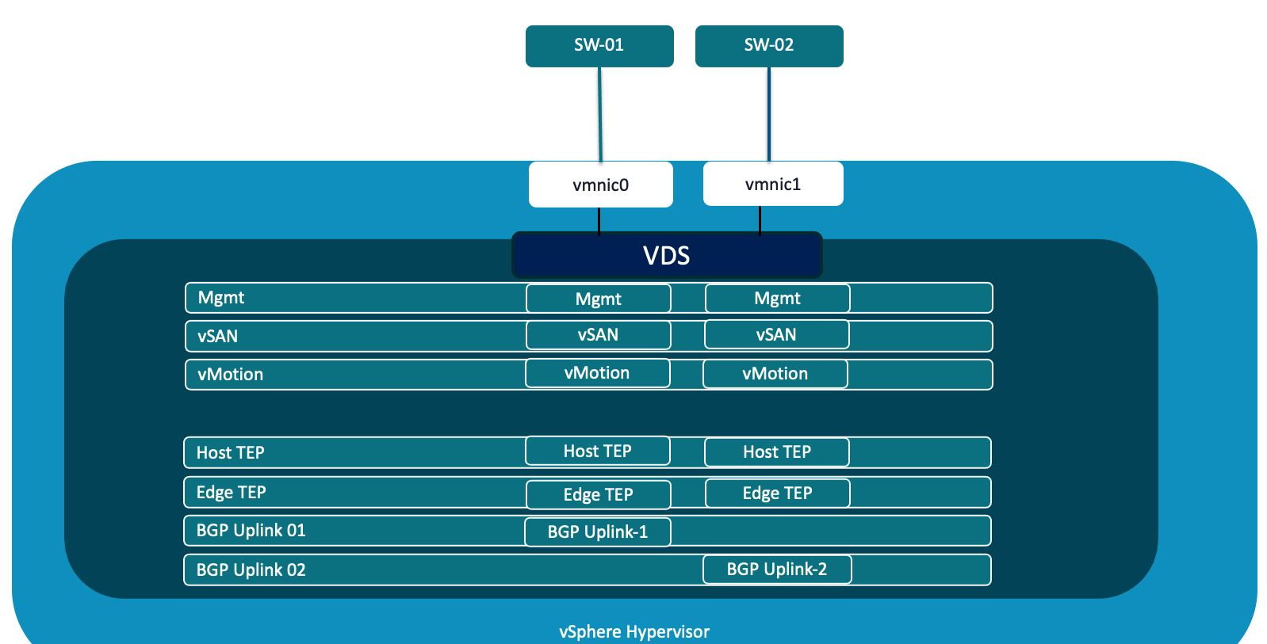

Figure 3-5. Workload Domain VDS Design
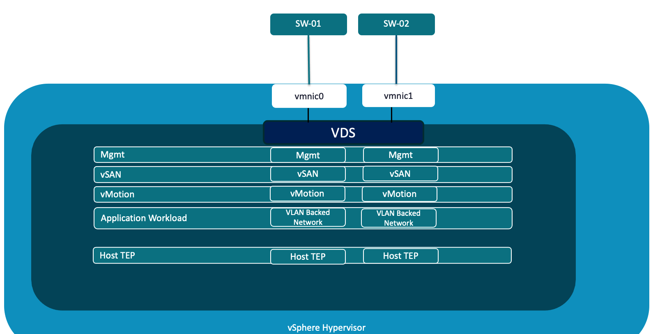

Table 3-4. VDS Design Decisions
Design Requirement ID | Design Requirement | Justification | Implication
VCF- VDS-CFG-001 | Use single vSphere Distributed switches for each cluster across all the Workload Domains. | Simplifies Management.  Current configuration with 2 25G will be sufficient to cater the traffic load. | None
NSX- VDS-CFG-002 | Enable vSphere Distributed Switch Health Check on all vSphere Distributed Switches. | vSphere Distributed Switch Health Check ensures that all VLANS are trunked to all ESXi Hosts attached to the vSphere Distributed Switch and ensures MTU sizes match the physical network. | You must have a minimum of two (2) physical uplinks to use this feature.  For VLAN and MTU checks, at least two physical NICs for the distributed switch are required.  For a teaming policy check, at least two physical NICs and two hosts are required when applying the policy.
NSX -VDS-CFG-003 | Use static port binding for all non-management port groups. | Static binding ensures a virtual machine connects to the same port on the vSphere Distributed Switch. This allows for historical data and port level monitoring. | None

Table 3-5. Portgroup Teaming
vSphere Distributed Switch | Portgroup Name | Port Binding | Teaming policy | Active Uplinks
vds01 | Management | Ephemeral Port Binding | Route based on physical NIC load | 1,2
vds01 | vMotion | Static Port Binding | Route based on physical NIC load | 1,2
vds01 | vSAN | Static Port Binding | Route based on SRC-ID | 1,2
vds01 | Auto Generated  Geneve (Transport Node – TEP) | Static Port Binding | Route based on SRC-ID | 1,2
vds01 | Auto Generated  Geneve (Edge Transport Node – TEP) | Static Port Binding | Route based on SRC-ID | 1,2
vds01 | Auto Generated  Geneve (Edge Transport Node – RTEP) | Static Port Binding | Failover Order | 1,2
vds01 | BGP Peering 1 | Static Port Binding | Failover Order | 1
vds01 | BGP Peering 2 | Static Port Binding | Failover Order | 2

VCF Fleet Level Components Network Design
For this Deployment Fleet level components will be deployed on Overlay based Network from NSX.

The fleet level management components will be deployed to an NSX overlay segment. This is done for the survivability of the Fleet components. This provides the option to use the NSX load balancer for fleet level management components including VCF Operations and VCF Automation. It also provides the option to stretch the networks using NSX Federation if a disaster recovery solution is layered on top.

Fleet Level Components on NSX Overlay Segment Model Attributes

Attribute | Details

Connectivity Type | NSX Segment Networking
Network Isolation | Yes, dedicated NSX Segment
NSX Edge Cluster | Required for connectivity
Stretching Network between availability zones | NSX segment is stretched using NSX Overlay segment available on hosts in the cluster
Stretching Network between regions | NSX Federation can be used to stretch the NSX segment

Figure 3-6. Fleet Level Components on NSX Overlay Segment Model
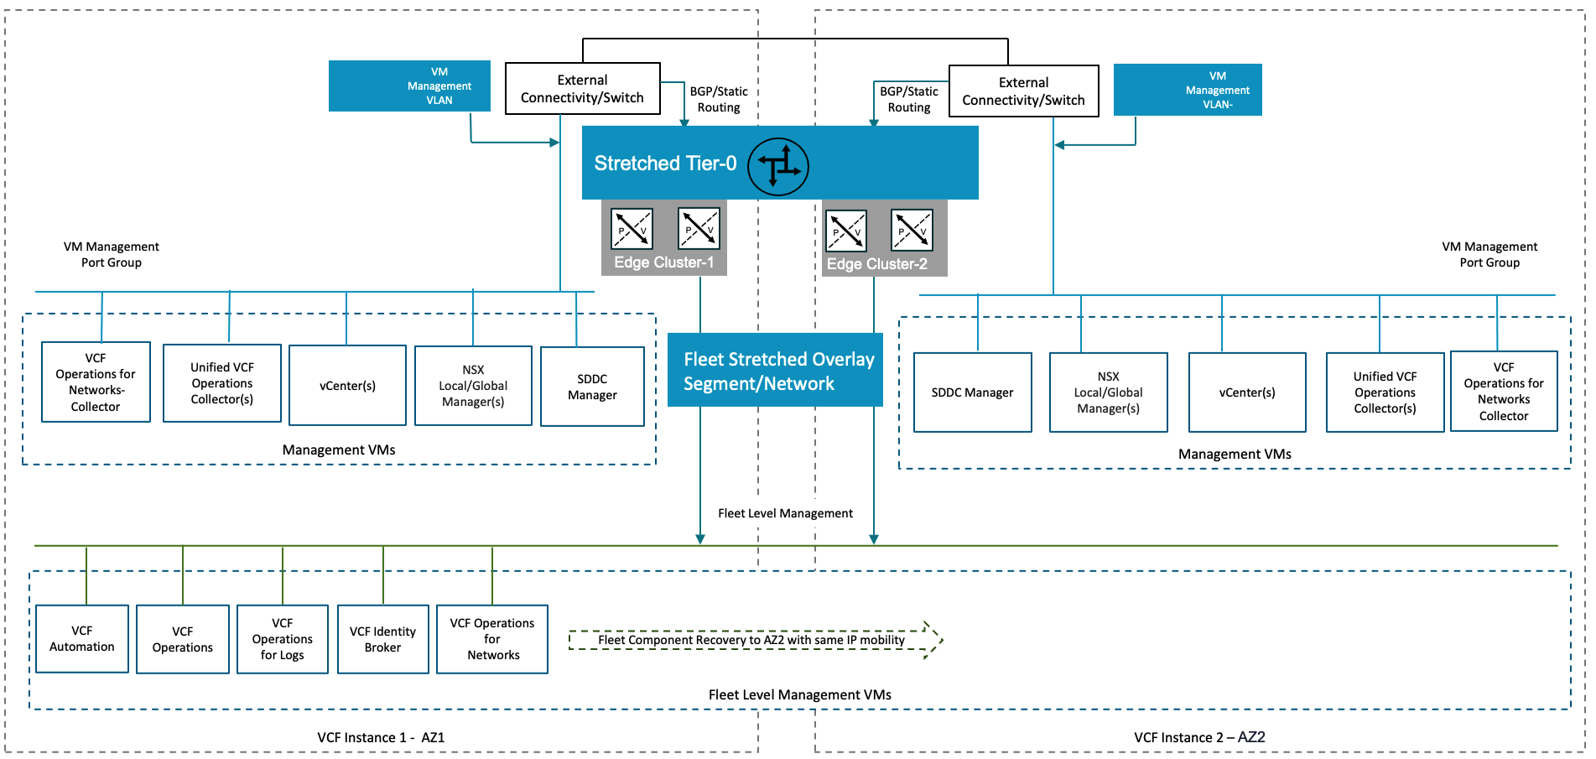

Figure 3-7. Fleet Level Components IP Mobility-DR
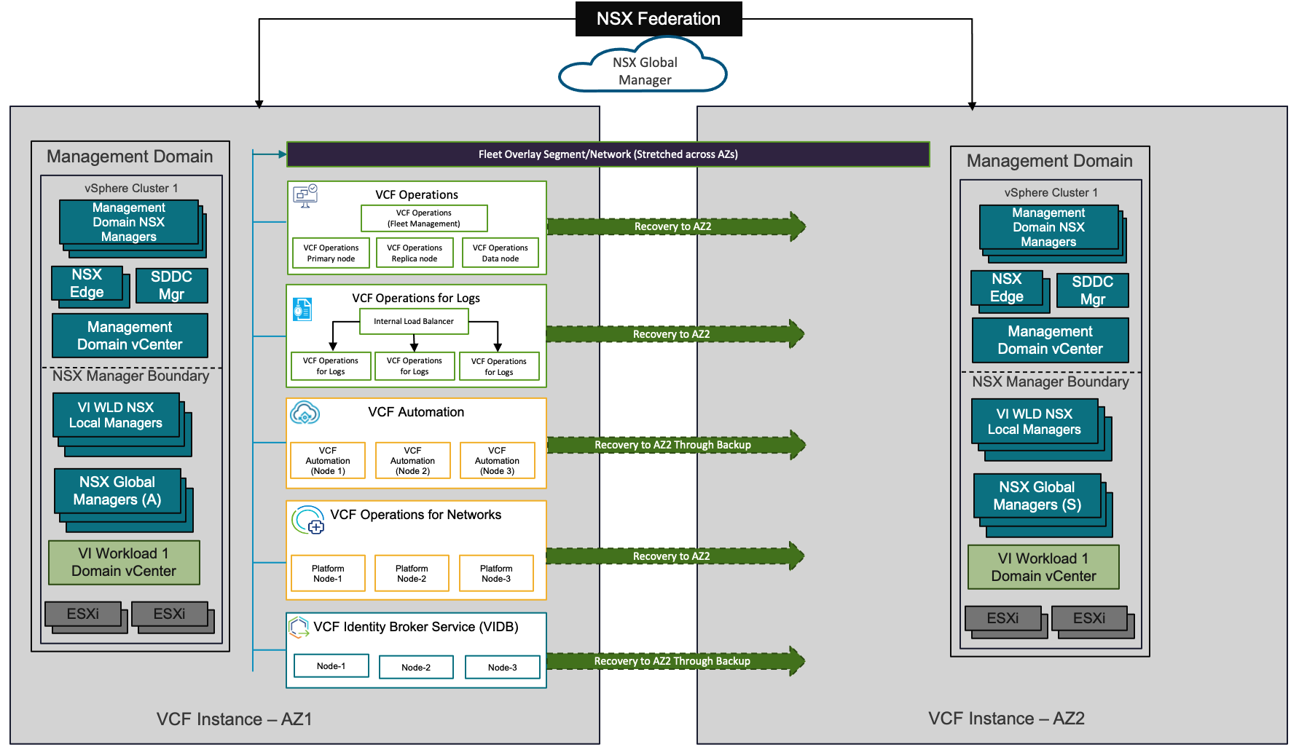

Table 3-6. Fleet Level Components Network Design Decisions
Note: For this design NSX Federation will be used, so all the Routing/Switching design decisions added in the NSX Federation section and will be created in Global Manager.

Design Requirement ID | Design Requirement | Justification | Implication
VCF-FLT-NSX-OVR-REQD-001 | Create NSX edge cluster with centralized transit gateway in the management domain | Provides T0 gateway routing to the physical network | Additional routing configuration needed on the physical switches, e.g. BGP or static routing
VCF-FLT-NSX-OVR-REQD-002 | Create a T1 gateway and link to the T0 gateway | Provides connectivity to other networks for the NSX segment used for the Fleet level components | Manually created in NSX manager UI
VCF-FLT-NSX-OVR-REQD-003 | On the T1 advertise all connected segments and service ports | Advertises the segment subnet to the T0 | None
VCF-FLT-NSX-OVR-REQD-004 | Create a segment on management domain overlay transport zone for Fleet Level components | Used for Fleet level component connectivity
VCF-FLT-NSX-OVR-REQD-005 | Use a segment on management domain overlay transport zone for Fleet Level components | - NSX Load balancer can be used for Fleet level components  - NSX Segment can be stretched between VCF instances using NSX Federation  - Provides IP Mobility if the NSX segment is stretched between sites | Requires additional manual steps for deployment
VCF-FLT-NSX-OVR-REQD-006 | Use SDDC Manager API to deploy the components day 2 | Provides the automated workflow to deploy the components to the dedicated network | - Fleet Level component install binaries must be downloaded to SDDC manager depot  - Json payload must be provided for the deployment

Transport Node and uplink Policy Design
A transport node is a node that can participate in an NSX overlay or NSX VLAN network. There are several types of transport nodes available in NSX.

N-VDS | N-VDS is a software-defined switch platform that is hypervisor independent. It is the primary component involved in the data plane of the transport nodes. N-VDS forwards traffic between components running on the transport node or between internal components and the physical network. In this AMEX design, N-VDS is only used for Edge Transport Nodes.
ESXi Host Transport Nodes | ESXi host transport nodes are ESXi hosts prepared by NSX.
Edge Nodes | NSX Edge nodes are service appliances that run network services that cannot be distributed to the hypervisors. They are grouped in one or several NSX edge clusters, each cluster representing a pool of capacity.

Table 3-7. Transport Node Design Decisions
Design Requirement ID | Design Requirement | Justification | Implication
NSX-AMEX-REQD-TNP-001 | Add as transport nodes all hosts prepared for NSX in the Workload Domain cluster. | Enables the participation of ESXi hosts and the virtual machines on them in NSX overlay and VLAN networks. | An additional VLAN is required for Edge nodes TEPs.
NSX-AMEX-REQD-TNP-002 | ESXi transport nodes and NSX Edge transport nodes will belong to the same overlay transport zone (different VLAN and subnet). | Edge Node VMs will run on NSX host Transport Nodes and distinct networks must be used in this instance for supported connectivity. | The overlay VLANs must be available where required in the physical fabric. The size of the overlay subnets is directly related to the number of TEP IPs required.
NSX-AMEX-REQD-TNP-003 | All ESXi Transport Nodes TEP IPs will be assigned using the pool. | As per VCF deployment standard all the TEP IPs will be assigned via pool from NSX.
NSX-AMEX-REQD-TNP-004 | Create an uplink profile with the load balance source teaming policy with two (2) active 25 GbE uplinks for ESXi hosts. | Supports the concurrent use of both physical NICs on the ESXi hosts that are configured as transport nodes for increased resiliency and performance. | This policy can only be used for ESXi hosts.
NSX-AMEX-REQD-TNP-005 | Create one uplink profile for the edge node with three teaming policies.  · Default teaming policy of load balance source both active uplinks uplink-1 and uplink-2.  · Named teaming policy of failover order with single active uplink uplink-1 without standby uplinks.  . Named teaming policy of failover order with single active uplink uplink-2 without standby uplinks. | · An NSX Edge node that uses a single N-VDS can have only one uplink profile.  · For increased resiliency and performance, supports the concurrent use of both edge uplinks through both physical NICs on the ESXi hosts.  · The default teaming policy increases overlay performance and availability by using multiple Host Overlay VMkernel ports and appropriate balancing of overlay traffic.  · By using named teaming policies, you can connect an edge uplink to a specific host uplink and from there to a specific top of rack switch in the data center.  · Enables ECMP in each availability zone because the NSX Edge nodes can uplink to the physical network over two different VLANs.  VLAN ID is required in the uplink profile. Hence, you must create an uplink profile for each VLAN used by the NSX Edge virtual machines. | None

NSX Edge Transport Design
NSX Edge Gateways interact with the physical network in the same way as physical routing devices and have the same logical and physical properties as physical routers. NSX Edge Transport Nodes provide a pool of capacity for running centralized services and connectivity to networks that are external to the NSX deployment.

External Connectivity | When overlay networks are used, external connectivity from the NSX domain is required and can be provided by using a Tier-0 gateway (hosted on NSX Edge Transport Nodes) via BGP or static routing.
Centralized Services | NSX Edge Gateways also support centralized services (e.g., NAT, load balancing, VPN) when they are required. Centralised services will run on the SR (Services Router) component of either Tier-0 or Tier-1 gateways.

Edge Transport Nodes are available in two form factors – VM and bare metal. Both leverage the data plane development toolkit (DPDK) for faster packet processing and high performance.
Current AMEX VCF design will be focused on the VM form factor.
In this design, the NSX Edge cluster for Mgmt domain runs on a shared edge and workload cluster. vSphere HA and vSphere DRS protect the NSX Edge appliances.

NSX Edge nodes connect to top of rack switches in each data center to support northbound uplinks and route peering for SDN network advertisement. This connection is specific to the leaf switch that you are connected to.

Edge VM Transport Node Design
NSX VM Edge in VM form factor can be installed using an OVA, OVF, or ISO file. NSX Edge VM is only supported on the ESXi host.
An NSX Edge VM has four internal interfaces:
· eth0 – reserved for management of the Edge VM.
· fp-eth0, fp-eth1, and fp-eth2 - interfaces are assigned to DPDK Fast Path. These interfaces are allocated for external connectivity to TOR switches and for NSX overlay tunnelling. There is complete flexibility in assigning Fast Path interfaces (fp-eth) for overlay or external connectivity. As an example, fp-eth0 could be assigned for overlay traffic with fp-eth1, fp-eth2, or both for external traffic.

Figure 3-8. NSX Edge Node Architecture
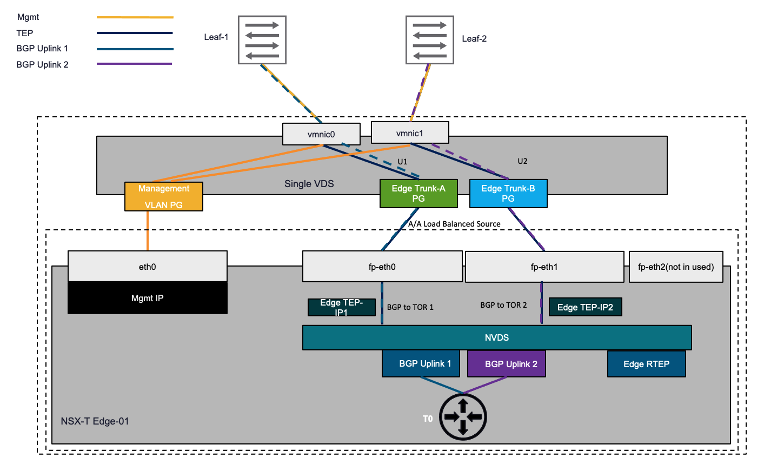

Table 3-8. Edge VM Design Decisions
Design Requirement ID | Design Requirement | Justification | Implication
NSX-AMEX-REQD-Edge-001 | A single N-VDS setup will be used for each NSX Edge VM. | ● Consistent deployment model for Edge VMs with a single N-VDS carrying both overlay and external traffic.  ● No change in the DVPG (Distributed Port Group) configuration when new service interfaces (workload VLAN segments) are added. | None
NSX-AMEX-REQD-Edge-002 | Two (2) TEPs will be configured on each NSX Edge VM. | Load Balancing of overlay traffic across multiple uplinks. | Extra IP addresses are required for Edge node TEP interfaces.
NSX-AMEX-REQD-Edge-003 | Interface eth0 is reserved for management and will be connected to a port group on VDS. | Edge VM management interface will be connected to management network available through INFRA-VDS | None.
NSX-AMEX-REQD-Edge-004 | Interface fp-eth0 and fp-eth1 in the NSX Edge VM will be used to connect to VDS trunk ports. | While the first vNIC (eth0) is reserved for management, the rest of the interfaces are assigned to DPDK Fast Path. There is complete flexibility in assigning Fast Path interfaces (fp-eth) for overlay or external connectivity. | None
NSX-AMEX-REQD-Edge-005 | Underlying VDS port groups will be configured as VLAN trunks for the transit networks, with respective VLAN tags configured on the NSX Edge uplink profiles and on the VLAN backed segments. | Improves manageability and provides more flexibility on NSX Edge uplinks configuration. | None
NSX-AMEX-REQD-Edge-006 | Use a dedicated VLAN for the NSX Edge Overlay network that is segmented from the Host Overlay VLAN. | The NSX Edge Overlay network must be isolated from the Host Overlay network to protect the Host Overlay traffic from NSX Edge- generated overlay traffic. | AMEX must have routing between the VLANs for NSX Edge Overlay and Host Overlay.  . AMEX must allocate another VLAN in the data center infrastructure for NSX Edge Overlay traffic.
NSX-AMEX-REQD-Edge-007 | All NSX Edge functions and services will be provided by NSX Edge Transport Node VMs. | The design requirements do not justify the deployment of bare-metal edges. | None
NSX-AMEX-REQD-Edge-008 | Use Large-size NSX Edge Transport Nodes for the Mgmt-Domain | A Large sized NSX Edge Transport Node would provide enough throughput for the Management cluster traffic.

Edge Cluster Design
An Edge cluster is a group of homogeneous Edge Transport Nodes – all VM or all bare metal – with common properties. It provides scale out, redundant, and high throughput gateway functionality for logical networks. Scale out from the logical networks to the Edge nodes is achieved using ECMP. An Edge Transport Node Cluster can, however, support heterogeneous Edge Transport Nodes to facilitate migration from Edge node VM to bare metal Edge Node.
There is a flexibility in assigning Tier-0 or Tier-1 gateways to Edge nodes and clusters. Tier-0 and Tier-1 gateways can be hosted on either the same or different Edge clusters.
Depending upon the services hosted on the Edge node and their usage, an Edge cluster could be dedicated simply for running centralised services (e.g., NAT, LB, FW, etc.), dedicated for running a router instance (ECMP with dynamic routing, static routing) or shared cluster running both – services and routing.
For AMEX NSX Edge nodes will be deployed only in Management Domain.

Figure 3-9. Edge Cluster Design
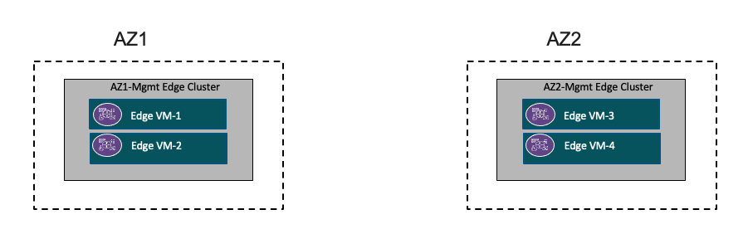

Table 3-9. Edge Cluster Design Decisions
Design Requirement ID | Design Requirement | Justification | Implication
NSX-AMEX-REQD-Edge_Cluster-001 | Apply VM-VM anti-affinity rules for vSphere DRS to the virtual machines of the NSX Edge cluster. | Keeps the NSX Edge nodes running on different ESXi hosts for high availability. | AMEX must perform additional tasks to set up the anti-affinity rules.
NSX-AMEX-REQD-Edge_Cluster-002 | In vSphere HA, set the restart priority policy for each NSX Edge appliance to high. | NSX Edge VMs are part of the north/south data path for overlay segments. High priority order ensures lower priority VMs will have connectivity.  Setting the restart priority to high reserves highest for future needs. | If the restart priority for another VM is set to highest, the connectivity delays for other appliances will be longer.
NSX-AMEX-REQD-Edge_Cluster-003 | Create an NSX edge cluster with the default Bi-Directional Forwarding Detection (BFD) settings containing the edge transport nodes | Satisfies availability requirements by default.  Edge clusters are required to create services such as NAT, routing to physical networks and load balancing. | None
NSX-AMEX-REQD-Edge_Cluster-004 | Create a resource pool for NSX Edge cluster and its NSX Edge appliances in the root of the workload cluster object.  Create a resource pool in the root of the workload cluster object for customer workloads. | Guarantees that the edge cluster receives sufficient compute resources during times of contention.
NSX-AMEX-REQD-Edge_Cluster-005 | Configure the edge resource pool with a 256-GB memory reservation and high CPU share value. | ● Guarantees that the edge cluster receives sufficient memory resources during times of contention.  ● Setting the CPU share value to high gives priority to edge appliances in times of CPU contention. | Tenant workloads might not be able to use their allocated memory or CPU during times of contention.

Transport Zone Design
Transport zones determine which hosts can be connected to a particular network. A transport zone identifies the type of traffic, VLAN or overlay, and the vSphere Distributed Switch name. AMEX can configure one or more VLAN transport zones and a single overlay transport zone per virtual switch. A transport zone does not represent a security boundary.
This section describes the NSX Transport Zone for both Management and Workload Domain.
· Overlay Transport Zone
· Host VLAN Transport Zone

Figure 3-10. Transport Design for Management Domain
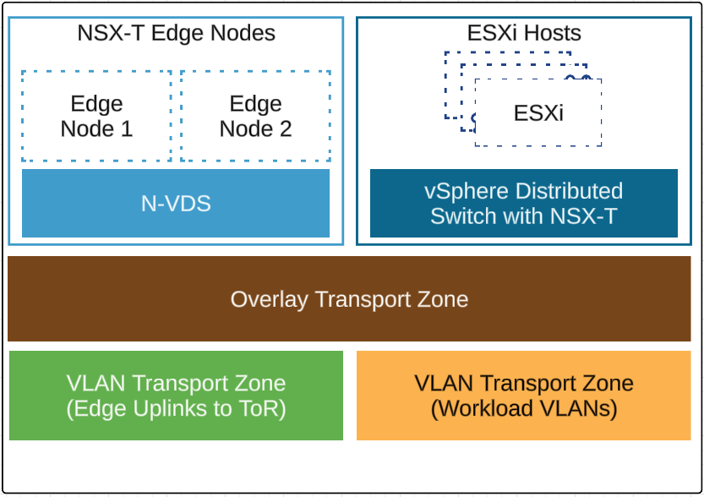
Figure 3-11. Transport Design for Workload Domain
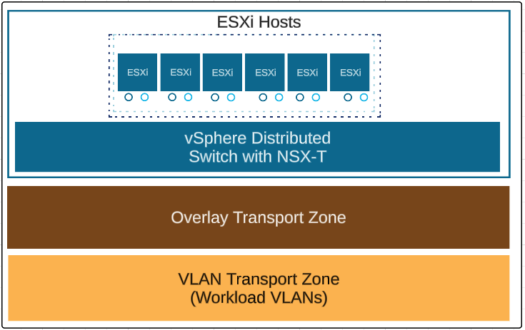

Geneve Overlay
Geneve provides the overlay capability in NSX to create isolated, multi-tenant broadcast domains across datacentre fabrics, and enables customers to create elastic, logical networks that span physical network boundaries.
In the vSphere architecture, the encapsulation is performed between the virtual NIC of the guest VM and the logical port on the virtual switch, making the Geneve overlay transparent to both the guest virtual machines and the underlying Layer 3 network. The Tier-0 router performs gateway services between overlay and non-overlay hosts (for example, a physical server or the Internet router). The NSX Edge virtual machine translates overlay segment IDs to VLAN IDs, so that non-overlay hosts can communicate with virtual machines on an overlay network.

Table 3-10. Geneve Overlay Design
Design Requirement ID | Design Requirement | Justification | Implication
NSX-AMEX-REQD-Geneve-001 | Use NSX to introduce overlay networks for workloads. | Simplifies the network configuration by using centralized virtual network management.  Currently only the Management domain using Overlay segment for Fleet component connections. | None
NSX-AMEX-REQD-Geneve-002 | To provide virtualized network capabilities to management workloads, use overlay networks with NSX Edge nodes and distributed routing. | Creates isolated, multi-tenant broadcast domains across datacentre fabrics to deploy elastic, logical networks that span physical network boundaries.  Enables advanced deployment topologies by introducing Layer 2 abstraction from the data center networks. | Requires configuring transport networks with an MTU size of at least 1600 bytes (more than 1700 bytes is recommended).
NSX-AMEX-REQD-Geneve-003 | Each ESXi host member of a cluster of the Service Workload domain must be connected to the overlay transport network. | The Overlay Transport network carries the VMs traffic connected to Segments. The ESXi Hosts must be connected to the overlay transport network and configured as Transport Nodes.  This also applies to the required Edge Nodes participating as Transport Nodes in the network and providing routing and stateful services for the environment. | Overlay transport network and VLAN transport network use the same physical NICs.

NSX Federation and Routing Design
AMEX has a requirement for Workload IP Mobility across the two AZs to host the Fleet Management Appliances. The solution of choice to deliver this capability is NSX Federation, and this design section will describe the additional components, services, considerations, etc., that are required to extend the core NSX Design and Configuration to enable IP Mobility in accordance with the original requirements.
For this VCF Design NSX Federation will be deployed only for Mgmt. Domain
Architecture Overview
NSX Federation solution introduces a new NSX Cluster entity called Global Manager, with the existing per-location NSX Clusters now called Local Managers. This Global Manager cluster offers the central configuration point in terms of the global networking and security services for all locations or Local Managers that participate in the Federation Domain. The Global Manager is responsible for managing these global objects and pushing the respective configuration to the Local Managers.

GM Cluster will be deployed in both locations as one active 3 node GM Cluster in AZ1 and one standby 3 node GM Cluster in AZ2.
Note-: Federation can support till 4 locations to span across the locations or regions.

Infrastructure objects (Edge Nodes, Edge Clusters, Hypervisors preparation, Transport Zones, etc) are always created and managed by Local Managers. Global Manager only consumes those when needed for the Global Manager object creation.

Figure 3-12. NSX Federation Logical Design
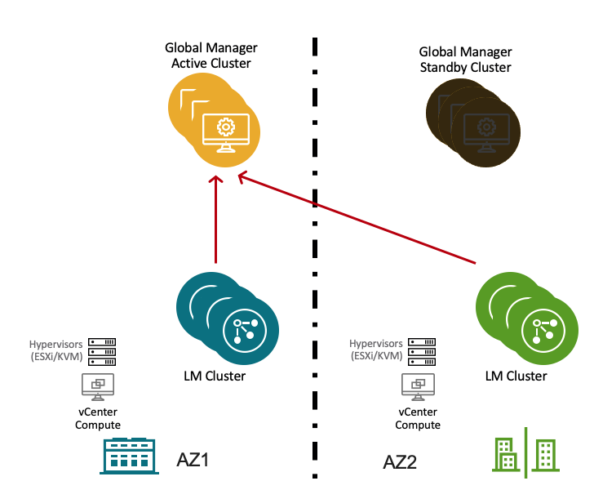

- LM in each Location
- GM Active in One Location
- GM Standby in second Location
- Register LMs to GM
- Two LM specific Regions and one Global Region
- Each cluster will have 3 nodes for high availability
- Each cluster will use VIP from same IP subnet as nodes

NSX Federation Tunnel Endpoints
In an NSX Federation environment, there are two types of tunnel endpoints.
- Tunnel End Point (TEP): the IP address of a transport node (Edge node or Host) used for Geneve encapsulation within a location (two active TEP interfaces are instantiated)
- Remote Tunnel End Points (RTEP): the IP address of a transport node (Edge node only) used for Geneve encapsulation across locations
Physical design and requirements
For a topology with multiple Federation regions/sites, specific requirements for the networking in each datacentre and between datacentres exist. These requirements extend those for the datacentre specific local NSX deployments.
In the AMEX NSX Federation deployment additional VLANs are required for remote tunnel end point (RTEP) traffic for the NSX Edge nodes in each of the AZs. Edge RTEP VLANs carry site-to-site data plane traffic. All Edge RTEP VLANs must be routable across the sites and NAT is currently not supported.
Federation Requirements
Component | Requirement
MTU | Set the MTU for the RTEP VLAN to 1,700 bytes or greater for best performance.
BGP | Each site must have its own ASN.  Provide upstream connectivity with BGP for North-South communication between AZ1 and AZ2.
Ingress and egress traffic | For NSX overlay segments that are not stretched between AZ1 and AZ2, traffic flows in and out of the datacentre where the local segment is located.  For NSX overlay segments that are stretched between AZ1and AZ2, traffic flows in and out of the primary location where the primary Tier-0 router is located. Local egress is not supported. Failover occurs over BGP route withdrawal or advertisement.
Latency | Intra-Datacentre:  Maximum network latency between NSX Managers nodes within an NSX Manager cluster (Local or Global) is 10 ms.  Maximum network latency between the NSX Manager cluster and transport nodes is 150 ms.  Inter-Datacentre:  Maximum network latency between the primary and standby NSX Global Manager clusters is 150 ms.  Maximum network latency between NSX Local Manager clusters is 150 ms.

Table 3-11. NSX Federation Design Decisions
Design Requirement ID | Design Requirement | Justification | Implication
NSX-AMEX-REQD-FED-001 | AZ1 and AZ2 deploy 3 Medium-size NSX Global Manager nodes with an internal VIP address for high availability.  The NSX Global Manager cluster is set as Active. | Medium size has enough capacity to support the initial deployment for Management Domain, as well as to accommodate any future growth of the environment. | NA
NSX-AMEX-REQD-FED-002 | Apply VM-VM anti-affinity rules in vSphere Distributed Resource Scheduler (vSphere DRS) to the NSX Global Manager appliances in both Datacentres. | Keeps the NSX Global Manager appliances running on different ESXi hosts for high availability. | AMEX must allocate at least four physical hosts so that the three NSX Manager appliances continue running if an ESXi host failure occurs.  AMEX must perform additional configuration for the anti-affinity rules.
NSX-AMEX-REQD-FED-003 | In vSphere HA, set the restart priority policy for each NSX Global Manager appliance to medium. | NSX Global Manager implements the management plane for global segments and firewalls. | Management of NSX global components will be unavailable until at least one NSX Global Manager virtual machine restarts.
NSX-AMEX-REQD-FED-004 | Place the appliances of the NSX Global Manager cluster on the management VLAN port group in each Datacentre. | Provides direct secure connection to the ESXi hosts, vCenter Server and NSX Local Managers for edge node management and distributed network services. | None

Edge Node Design for Federation
In an NSX Federation deployment, each AZs has its own NSX Edge cluster. In each AZs, the edge nodes and clusters are deployed with the same design as but with site-specific settings such as IP addressing, VLAN IDs, and names. Each edge cluster is managed by the NSX Local Manager instance for that site.
Configure Edge Nodes for Stretched Networking
Before AMEX creates gateways and segments that span more than one location, AMEX must configure a remote tunnel endpoint (RTEP) on Edge nodes in each location to handle the cross-location traffic. All Edge nodes in the cluster must have an RTEP configured.

Table 3-12. NSX Federation RTEP Design Decisions
Design Requirement ID | Design Requirement | Justification | Implication
NSX-AMEX-REQD-FED_Edge-001 | Allocate a separate VLAN for edge RTEP overlay that is different from the edge TEP overlay VLAN. | The RTEP network must be allocated a VLAN that is different from the edge TEP VLAN.  Dedicated VLAN for inter-site communication. | AMEX must allocate another VLAN in each Datacentre infrastructure for edge RTEP overlay.Also need to open the respective Firewall ports to communicate.

Routing Design
AMEX Mgmt routing design with NSX Federation shall support network spans between both AZs for applications that require resilient connectivity at multiple locations and to enable granular control of traffic from and to each Datacentre.
Each AZs will have two NSX Edge clusters with associated uplink VLANs for north-south traffic flow for that Datacentre.
NSX Tier-0 Gateways will be deployed to form BGP neighbor relationships with the upstream Cisco devices. This will allow for networks created in NSX to be advertised to the AMEX network.

Management Domain will have Stretched Tier-0 between both sites.
In this design, an NSX Tier-0 will be deployed as Active/Active Primary/Secondary locations. During a Datacentre failure, the network component will automatically be made primary at the alternate location.

Tier-0 Gateways
In the NSX Federation, a Tier-0 gateway can span multiple locations. Each Datacentre contains a logical unit of the Tier-0 gateway which is assigned to the edge cluster in the corresponding NSX Cluster and is configured to interface with the local top of rack switches in the Datacentre.
Stretched Active-Active Tier-0 Gateway with Primary and Secondary Locations
In an active-active Tier-0 gateway with primary and secondary locations, the following applies:
· All Edge nodes are active at the same time; therefore, the Tier-0 cannot run stateful services.
· All traffic enters and leaves through the Edge nodes in the primary location.
An important note for this topology is that NSX ensures that all egress traffic leaves through the primary location. However, in the case of an external firewall that exists on the path, AMEX must ensure that the return traffic enters through the primary location as well, otherwise return traffic via the secondary location might be blocked. If required, this can be mitigated by adding AS path prepending on the stretched Tier-0 for the BGP peers in the secondary location (Local Pref is only applied within AS, so will not have an effect for inbound path selection).

Figure 3-13. NSX Federation Routing Design
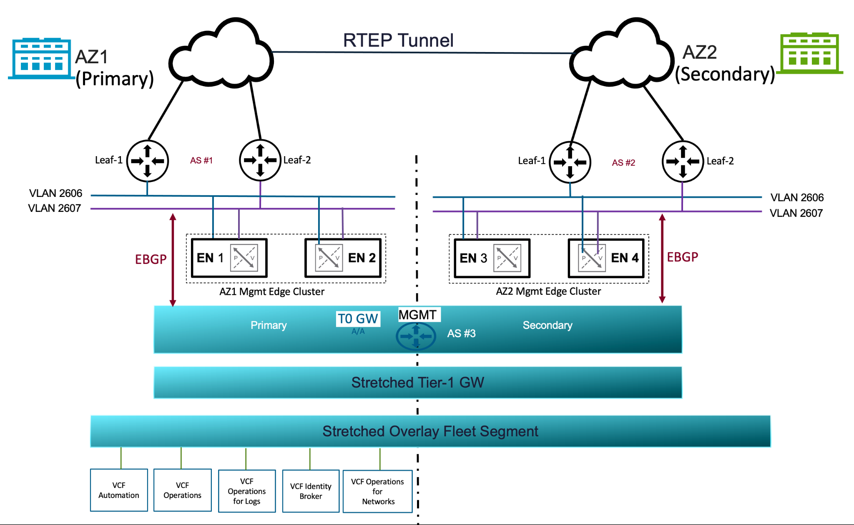

Table 3-13. NSX Federation Routing Design Decisions
Design Requirement ID | Design Requirement | Justification | Implication
NSX-AMEX-REQD-FED_Routing-001 | - Create an Active-Active / location Primary-Secondary Tier-0 gateway that is stretched between AZ1 and AZ2  - Set the Tier-0 gateway as Primary in AZ1 and Secondary in AZ2 | - Supports ECMP north-south routing on all nodes in the NSX Edge cluster.  - In NSX Federation, a Tier-0 gateway lets egress traffic from connected gateways only in its primary location.  - If a region failure occurs, the region-specific networking in the other regions will remain available without manual intervention. | Active-active Tier-0 gateways cannot provide stateful services such as NAT.
NSX-AMEX-REQD-FED_Routing-002 | Establish BGP neighbor peering to the top of rack switches in each Datacenter. | Enables the learning and advertising of routes between the sites. Facilitates the automated failover of networks from the primary to the secondary site. | None
NSX-AMEX-REQD-FED_Routing-003 | Create a Active/Standby stretched Tier-1 Gateway and connect it to the Tier-0 Gateway | Allows for creation of one or more cross-location NSX virtual network segments for workloads which require IP mobility between locations. Active/Standy in Tier-1 will ensure the traffic to egress and Ingress from AZ1. | With Tier-1 Active/Standby it will add one additional hop in the virtual network and also it will use a single edge node in the Tier-1 to process the Routing.
NSX-AMEX-REQD-FED_Routing-004 |  | As this design will be based on Active/Active Primary/Secondary, So for Fleet Overlay segments Egress/Ingress will happen from AZ1. To maintain symmetric routing need to add BGP AS Path prepend in the AZ2 BGP peer. | None
Disaster Recovery
In an NSX Federation environment, if you lose your active Global Manager, you can switch to the standby Global Manager.
If a Local Manager is lost, you can recover networking configurations from it using the auto detected Network Recovery option in the Global Manager.
In the case of stretched Tier-0 and Tier-1 without services, data plane traffic still works after the loss of the primary Location Manager. Network Recovery is not mandatory for the recovery of data plane, even though the Network Recovery option appears in the Global Manager.

Figure 3-14. NSX Federation Failover
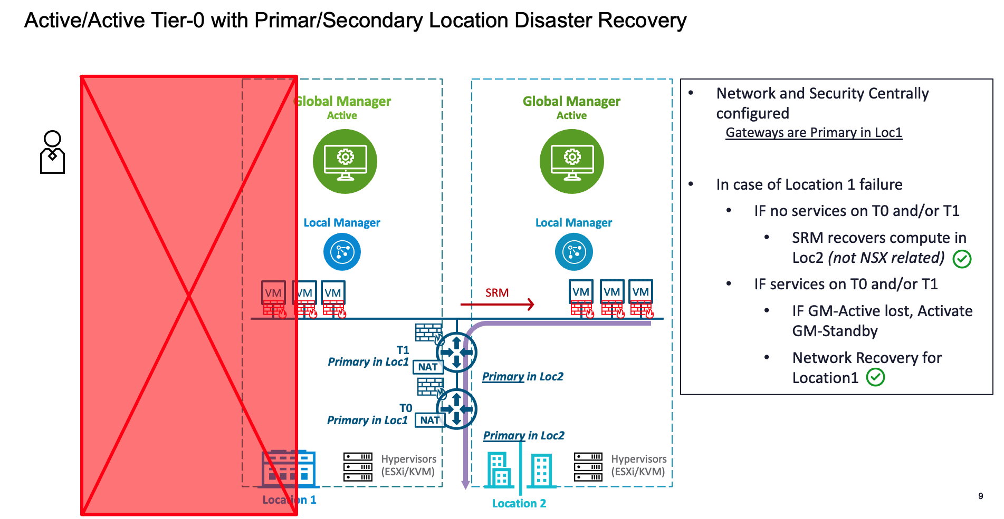

Lifecycle Management
In an NSX Federated environment, the NSX Global Manager and NSX instances in the individual workload domains must be compatible and supported versions with each other both during the upgrade and post-upgrade. To manage the life cycle of NSX Global Manager, use the Upgrade Coordinator on the NSX Global Manager appliances. The version of SDDC Manager in AMEX VMware Cloud Foundation Design does not handle the life cycle of NSX Global Manager nodes. For the NSX Local Manager appliances, you continue using SDDC Manager.
The Local NSX Manager lifecycle will be managed through SDDC.

Table 3-14. Lifecycle Management
Design Requirement ID | Design Requirement | Justification | Implication
NSX-AMEX-REQD-Lifecycle-001 | Use NSX Upgrade Coordinator to perform life cycle management on the NSX Global Manager appliances | The version of SDDC Manager in AMEX VMware Cloud Foundation Design is not currently capable of life cycle operations (patching, update, or upgrade) for NSX Global Manager. | You must always align the version of the NSX Global Manager nodes with the rest of the SDDC stack in VCF.  You must explicitly plan upgrades of the NSX Global Manager nodes. An upgrade of the NSX Global Manager nodes might require a cascading upgrade of the NSX Local Manager nodes and underlying SDDC Manager infrastructure prior to upgrade of the NSX Global Manager nodes.
NSX-AMEX-REQD-Lifecycle-002 | Establish an operations practice to ensure that prior to the upgrade of the NSX Global Manager, the impact of any version change is evaluated against the existing NSX Local Manager nodes and workload domains. | The versions of NSX Global Manager and NSX Local Manager nodes must be compatible with each other.  Because the version of SDDC Manager currently does not provide life cycle operations (patching, update, or upgrade) for the NSX Global Manager nodes, upgrading to an unsupported version cannot be prevented. | The administrator must establish and follow an operational practice by using a runbook or automated process to ensure a fully supported and compliant bill of materials prior to any upgrade operation.
NSX-AMEX-REQD-Lifecycle-003 | Use SDDC Manager to manage the Local NSX Manager nodes | As part of the VCF workflow, the lifecycle of local NSX appliances will be managed through SDDC. | None

Backup and Restore
It is critical that NSX Manager is backed up on a regular basis. Backup system configuration is provided by the NSX Manager appliance interface. Backups can be scheduled on an hourly, daily, or weekly basis, down to the minute. The backup file is saved to a remote location that the NSX Manager can access through FTP or SFTP. It is possible to exclude logs and flow data from backups.
FTP and SFTP are currently the only available options for backup of the NSX Manager. SFTP is recommended for increased security.
A backup can only be restored into a new NSX Manager instance, not on an existing appliance previously configured.

In the context of VMware Cloud Foundation, the SDDC Manager does not have visibility and control over the Global Manager Cluster. Therefore, backup configuration is done externally to the SDDC Manager, on the Global Manager cluster itself.
The system treats backup and restores operations as specific to each appliance. The Global Manager's backup contains a backup of the database of that appliance only.

Table 3-15. Backup and Restore
Design Requirement ID | Design Requirement | Justification | Implication
NSX-AMEX-REQD-Backup-001 | NSX Manager backups will be created using the internal backup utility. | The VMware recommended approach for achieving a consistent backup state, encapsulating all relevant NSX Manager data, is to use the internal backup mechanisms compared with an image-level snapshot backup. This will make sure that all relevant data is reinstated upon a restore. | The NSX Manager backup will be handled separately from the other virtual machines in the management cluster.
NSX-AMEX-REQD-Backup-002 | NSX Manager backup’s location will be within the SDDC Manager appliance VM. | As per VCF standard deployment NSX Manager backups will be configured to upload the config to the SDDC Manager appliance VM. | NSX Manager configuration backup will be within the SDDC Manager VM backup.
NSX-AMEX-REQD-Backup-003 | Configure the NSX Global Manager backup’s location to be an external SFTP server. | Each NSX Global Manager must be backed up according to the backup policies of AMEX.NSX backups will be performed on to an SFTP backup server in both AZs. | Additional configuration required.

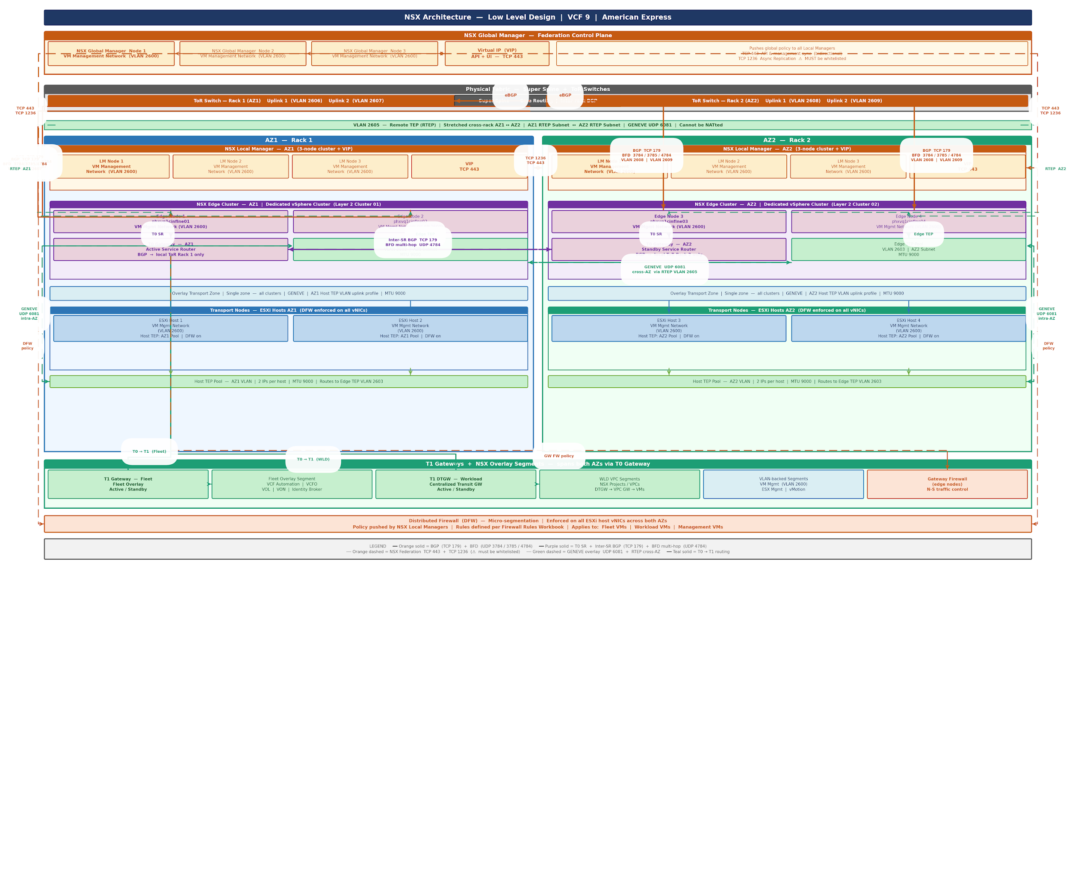
Appendix

References
For more information, see the following supplemental configuration and administration guides, white papers and best practices documents.
VMware Pro Cloud Services for Private Cloud Solution References
Remember Refine or add any additional links to product documentation
See the VMware Cloud Foundation Documentation (https://techdocs.broadcom.com/us/en/vmware-cis/vcf/vcf-9-0-and-later/9-0.html) for product documentation for Cloud Foundation.
The information is arranged by topics that include the following:
- VMware Cloud Foundation 9.0 Release Notes
- VMware Cloud Foundation Planning and Preparation Workbook
- VMware Cloud Foundation Design Guide
- VMware Cloud Foundation Deployment, Convergence and Upgrade Guide
- VMware Cloud Foundation Building Cloud Infrastructure Guide
- VMware Cloud Foundation vSphere Guide
- VMware Cloud Foundation vSAN Guide
- VMware Cloud Foundation NSX Guide
- VMware Cloud Foundation Lifecycle Management Guide
- VMware Cloud Foundation Fleet Management Guide
- VMware Cloud Foundation Infrastructure Operations Guide
- VMware Cloud Foundation Workload Monitoring and Observability Guide
- VMware Cloud Foundation vSphere Supervisor Platform Guide
- VMware Cloud Foundation Security and Compliance Guide
- VMware Cloud Foundation API Reference Guide
VMware Validated Solutions Guides:
- <Add as apporpriate>

